**BIN MUJEEB LOGISTICS - WEBSITE CONTENT REVIEW**

Please review each section below and provide your updated content in the answer fields.

# **SECTION 1: HEADER/NAVBAR**

**

**Question 1.1: What should be the company logo text?**

Current Answer: Bin Mujeeb

Your Updated Answer: _________________________________________________

# **SECTION 2: HOME PAGE - HERO SECTION**

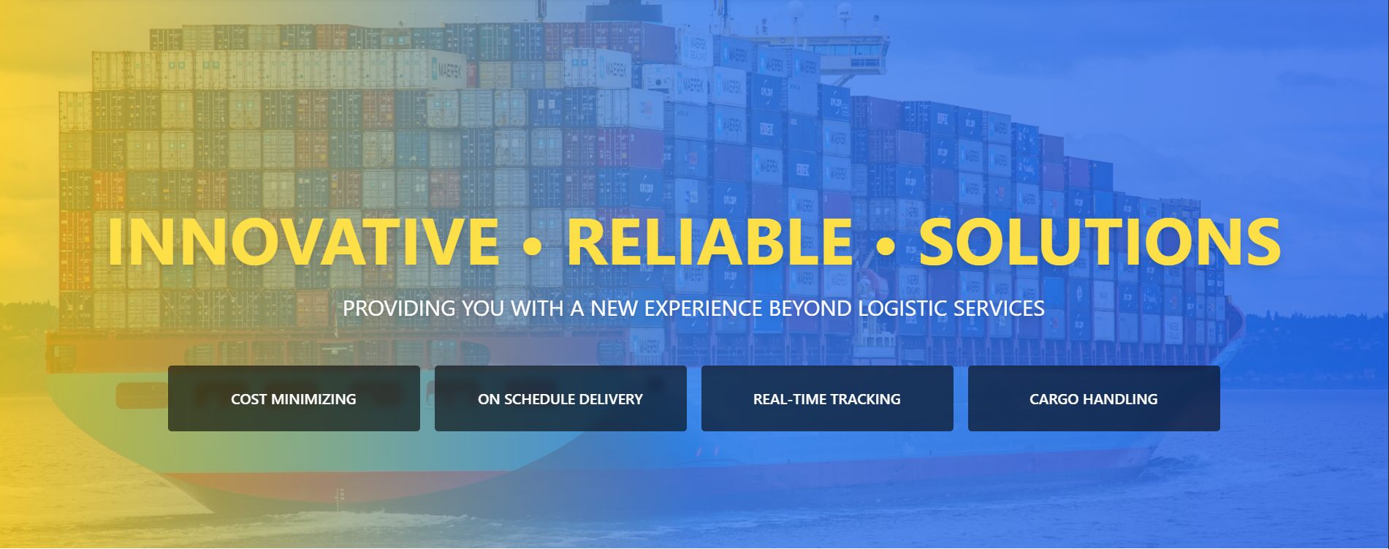

**Question 2.1: What should be the main hero heading?**

Current Answer: INNOVATIVE • RELIABLE • SOLUTIONS

Your Updated Answer: _________________________________________________

**Question 2.2: What should be the hero subtitle?**

Current Answer: PROVIDING YOU WITH A NEW EXPERIENCE BEYOND LOGISTIC SERVICES

Your Updated Answer: _________________________________________________

**Question 2.3: What are the four feature boxes? (Please list all four)**

Current Answers:

1. COST MINIMIZING

2. ON SCHEDULE DELIVERY

3. REAL-TIME TRACKING

4. CARGO HANDLING

Your Updated Answers:

1. _________________________________________________

2. _________________________________________________

3. _________________________________________________

4. _________________________________________________

# **SECTION 3: HOME PAGE - ABOUT US SECTION**

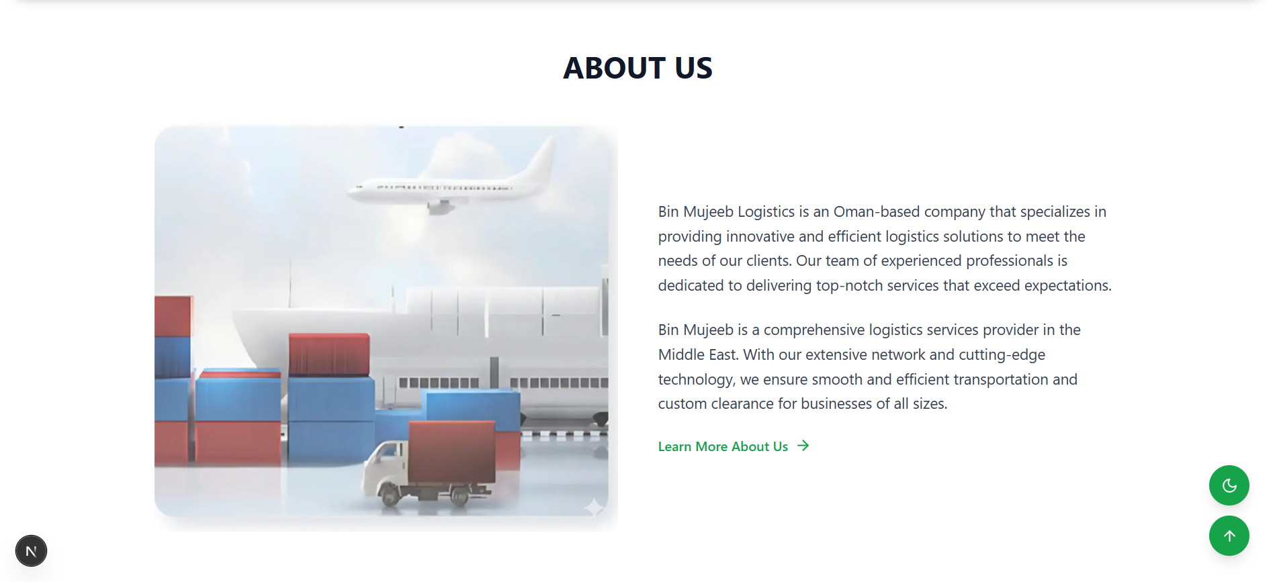

**Question 3.1: What should be the About Us description (first paragraph)?**

Current Answer: Bin Mujeeb Logistics is an Oman-based company that specializes in providing innovative and efficient logistics solutions to meet the needs of our clients. Our team of experienced professionals is dedicated to delivering top-notch services that exceed expectations.

Your Updated Answer: _________________________________________________

**Question 3.2: What should be the About Us description (second paragraph)?**

Current Answer: Bin Mujeeb is a comprehensive logistics services provider in the Middle East. With our extensive network and cutting-edge technology, we ensure smooth and efficient transportation and custom clearance for businesses of all sizes.

Your Updated Answer: _________________________________________________

# **SECTION 4: SERVICES PAGE - OUR SERVICES BANNER**

****Question 4.1: What should be the main heading?**

Current Answer: OUR SERVICES

Your Updated Answer: _________________________________________________

**Question 4.2: What should be the subtitle?**

Current Answer: Comprehensive logistics solutions for your business needs

Your Updated Answer: _________________________________________________

# **SECTION 5: HOW WE WORK**

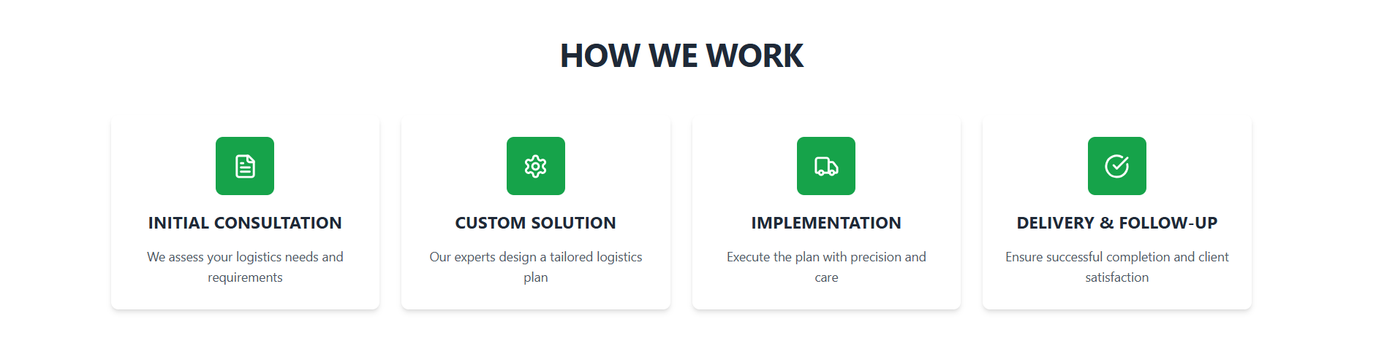

**Question 5.1: Card 1 - What should be the title?**

Current Answer: INITIAL CONSULTATION

Your Updated Answer: _________________________________________________

**Question 5.2: Card 1 - What should be the description?**

Current Answer: We assess your logistics needs and requirements

Your Updated Answer: _________________________________________________

**Question 5.3: Card 2 - What should be the title?**

Current Answer: CUSTOM SOLUTION

Your Updated Answer: _________________________________________________

**Question 5.4: Card 2 - What should be the description?**

Current Answer: Our experts design a tailored logistics plan

Your Updated Answer: _________________________________________________

**Question 5.5: Card 3 - What should be the title?**

Current Answer: IMPLEMENTATION

Your Updated Answer: _________________________________________________

**Question 5.6: Card 3 - What should be the description?**

Current Answer: Execute the plan with precision and care

Your Updated Answer: _________________________________________________

**Question 5.7: Card 4 - What should be the title?**

Current Answer: DELIVERY & FOLLOW-UP

Your Updated Answer: _________________________________________________

**Question 5.8: Card 4 - What should be the description?**

Current Answer: Ensure successful completion and client satisfaction

Your Updated Answer: _________________________________________________

# **SECTION 6: CORE CAPABILITIES**

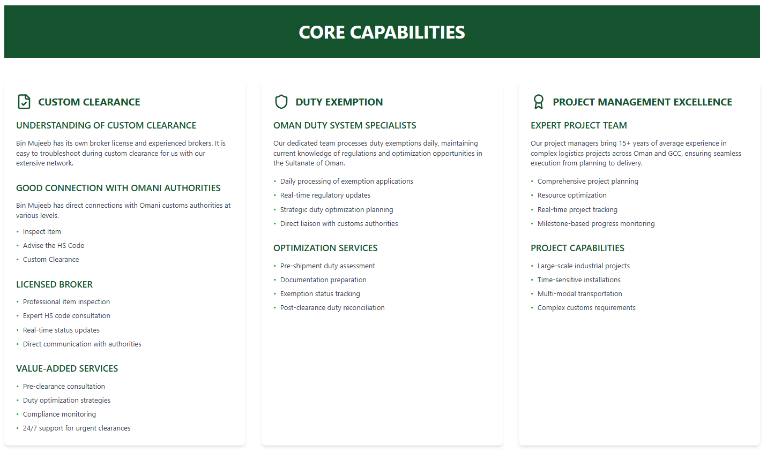

**Question 6.1: Column 1 - CUSTOM CLEARANCE - 'UNDERSTANDING OF CUSTOM CLEARANCE' description?**

Current Answer: Bin Mujeeb has its own broker license and experienced brokers. It is easy to troubleshoot during custom clearance for us with our extensive network.

Your Updated Answer: _________________________________________________

**Question 6.2: Column 1 - 'GOOD CONNECTION WITH OMANI AUTHORITIES' description?**

Current Answer: Bin Mujeeb has direct connections with Omani customs authorities at various levels.

Your Updated Answer: _________________________________________________

**Question 6.3: Column 2 - DUTY EXEMPTION - 'OMAN DUTY SYSTEM SPECIALISTS' description?**

Current Answer: Our dedicated team processes duty exemptions daily, maintaining current knowledge of regulations and optimization opportunities in the Sultanate of Oman.

Your Updated Answer: _________________________________________________

**Question 6.4: Column 3 - PROJECT MANAGEMENT EXCELLENCE - 'EXPERT PROJECT TEAM' description?**

Current Answer: Our project managers bring 15+ years of average experience in complex logistics projects across Oman and GCC, ensuring seamless execution from planning to delivery.

Your Updated Answer: _________________________________________________

# **SECTION 7: TRANSPORTATION SOLUTIONS**

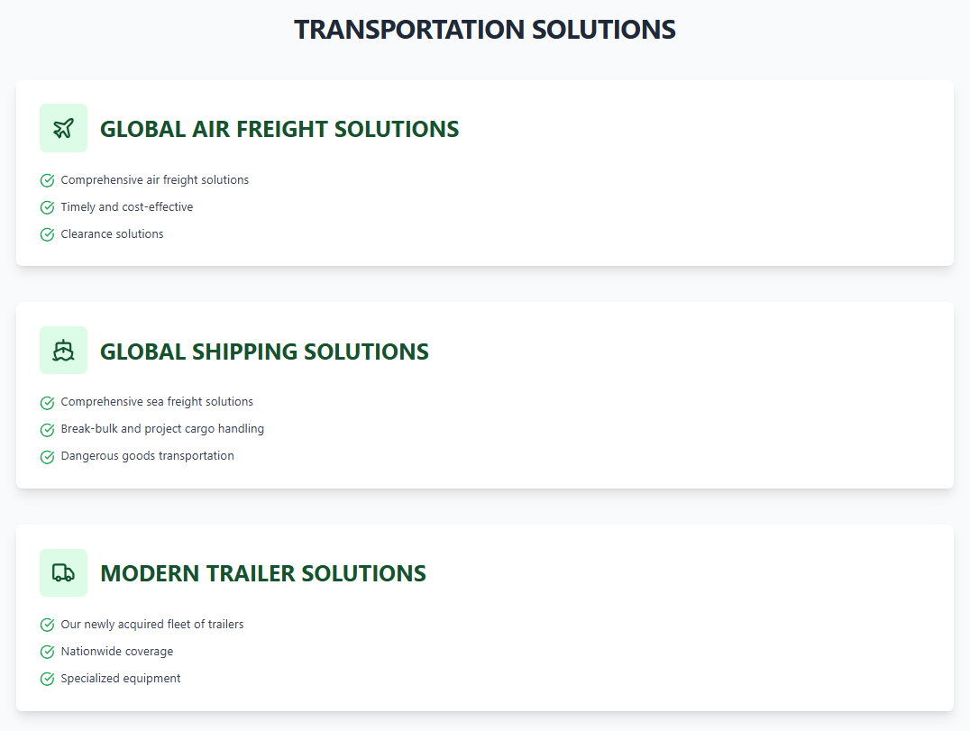

**Question 7.1: GLOBAL AIR FREIGHT SOLUTIONS - What are the key points? (List all)**

Current Answers:

• Comprehensive air freight solutions

• Timely and cost-effective

• Clearance solutions

Your Updated Answers:

• _________________________________________________

• _________________________________________________

• _________________________________________________

**Question 7.2: GLOBAL SHIPPING SOLUTIONS - What are the key points? (List all)**

Current Answers:

• Comprehensive sea freight solutions

• Break-bulk and project cargo handling

• Dangerous goods transportation

Your Updated Answers:

• _________________________________________________

• _________________________________________________

• _________________________________________________

**Question 7.3: MODERN TRAILER SOLUTIONS - What are the key points? (List all)**

Current Answers:

• Our newly acquired fleet of trailers

• Nationwide coverage

• Specialized equipment

Your Updated Answers:

• _________________________________________________

• _________________________________________________

• _________________________________________________

# **SECTION 8: SERVICE CATEGORIES**

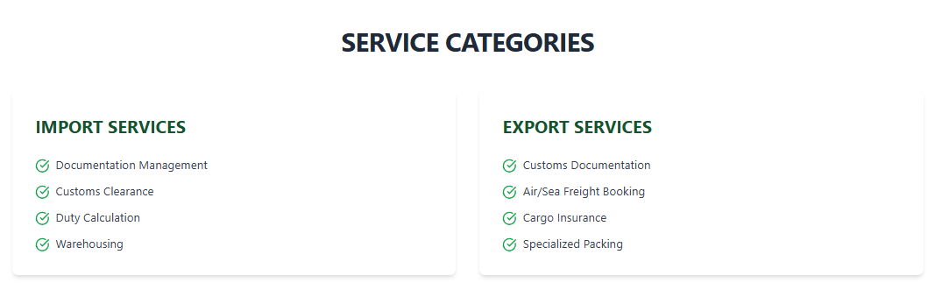

**Question 8.1: IMPORT SERVICES - What services should be listed? (List all)**

Current Answers:

• Documentation Management

• Customs Clearance

• Duty Calculation

• Warehousing

Your Updated Answers:

• _________________________________________________

• _________________________________________________

• _________________________________________________

• _________________________________________________

**Question 8.2: EXPORT SERVICES - What services should be listed? (List all)**

Current Answers:

• Customs Documentation

• Air/Sea Freight Booking

• Cargo Insurance

• Specialized Packing

Your Updated Answers:

• _________________________________________________

• _________________________________________________

• _________________________________________________

• _________________________________________________

# **SECTION 9: INDUSTRY-SPECIFIC SOLUTIONS**

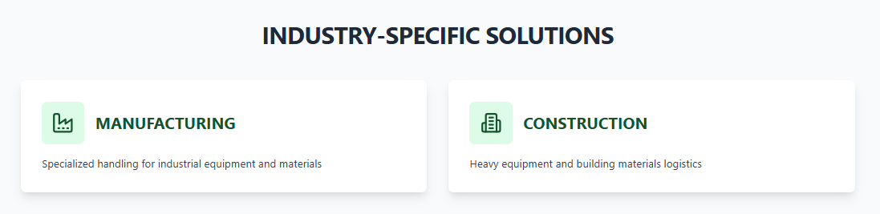

**Question 9.1: MANUFACTURING - What should be the description?**

Current Answer: Specialized handling for industrial equipment and materials

Your Updated Answer: _________________________________________________

**Question 9.2: CONSTRUCTION - What should be the description?**

Current Answer: Heavy equipment and building materials logistics

Your Updated Answer: _________________________________________________

# **SECTION 10: READY TO GET STARTED?**

**

**Question 10.1: What should be the main heading?**

Current Answer: READY TO GET STARTED?

Your Updated Answer: _________________________________________________

**Question 10.2: What should be the subtitle?**

Current Answer: Let us handle your logistics needs with expertise and precision.

Your Updated Answer: _________________________________________________

# **SECTION 11: ABOUT PAGE**

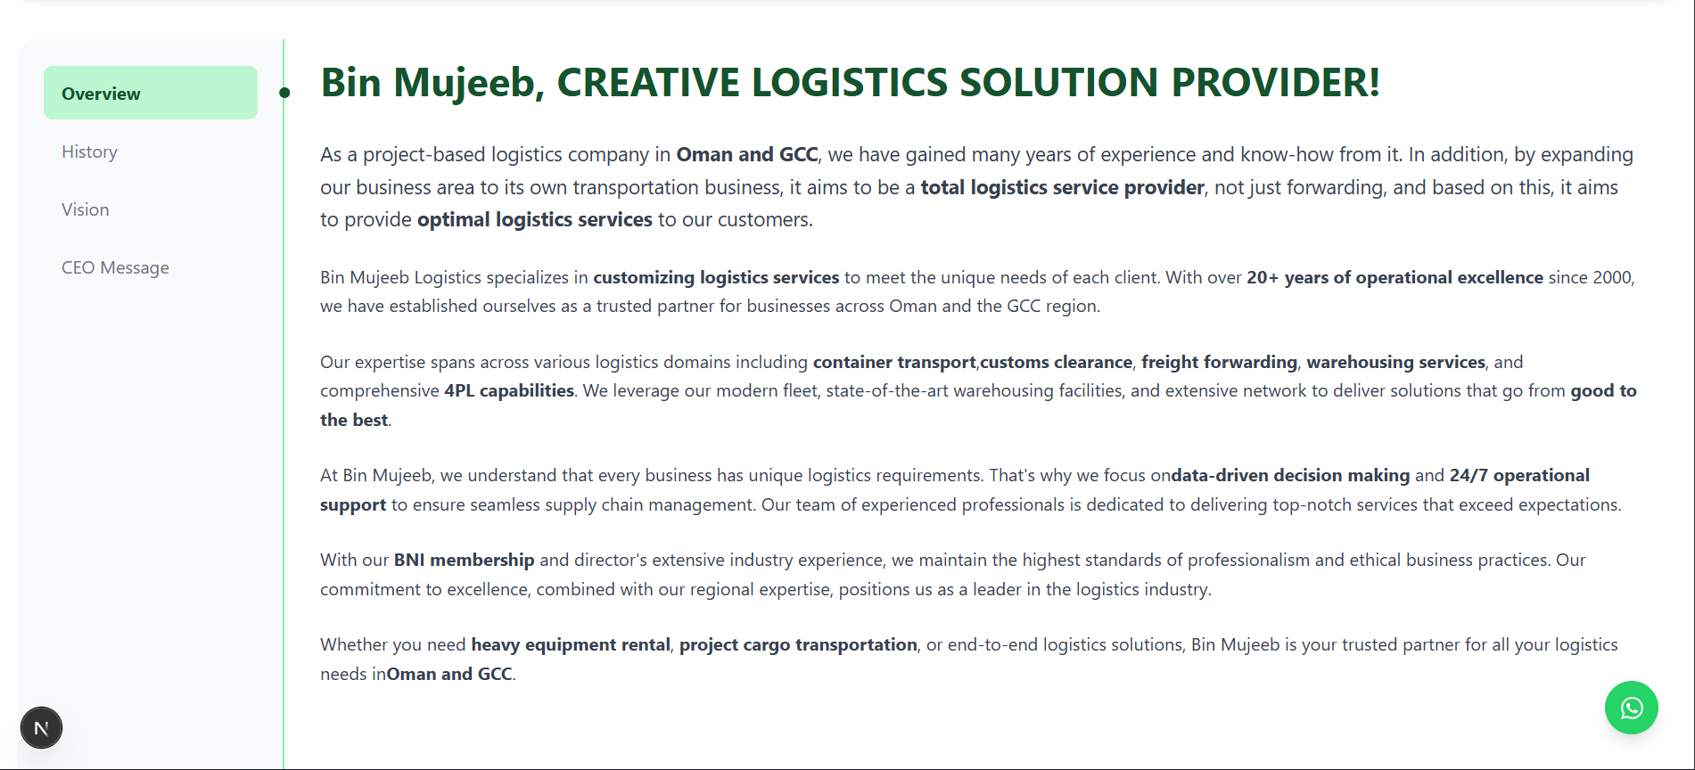

**Question 11.1: What should be the main heading?**

Current Answer: Bin Mujeeb, CREATIVE LOGISTICS SOLUTION PROVIDER!

Your Updated Answer: _________________________________________________

**Question 11.2: What should be the first paragraph?**

Current Answer: As a project-based logistics company in Oman and GCC, we have gained many years of experience and know-how from it. In addition, by expanding our business area to its own transportation business, it aims to be a total logistics service provider, not just forwarding, and based on this, it aims to provide optimal logistics services to our customers.

Your Updated Answer: _________________________________________________

**Question 11.3: What should be the second paragraph?**

Current Answer: Bin Mujeeb Logistics specializes in customizing logistics services to meet the unique needs of each client. With over 20+ years of operational excellence since 2000, we have established ourselves as a trusted partner for businesses across Oman and the GCC region.

Your Updated Answer: _________________________________________________

# **SECTION 11A: HISTORY PAGE**

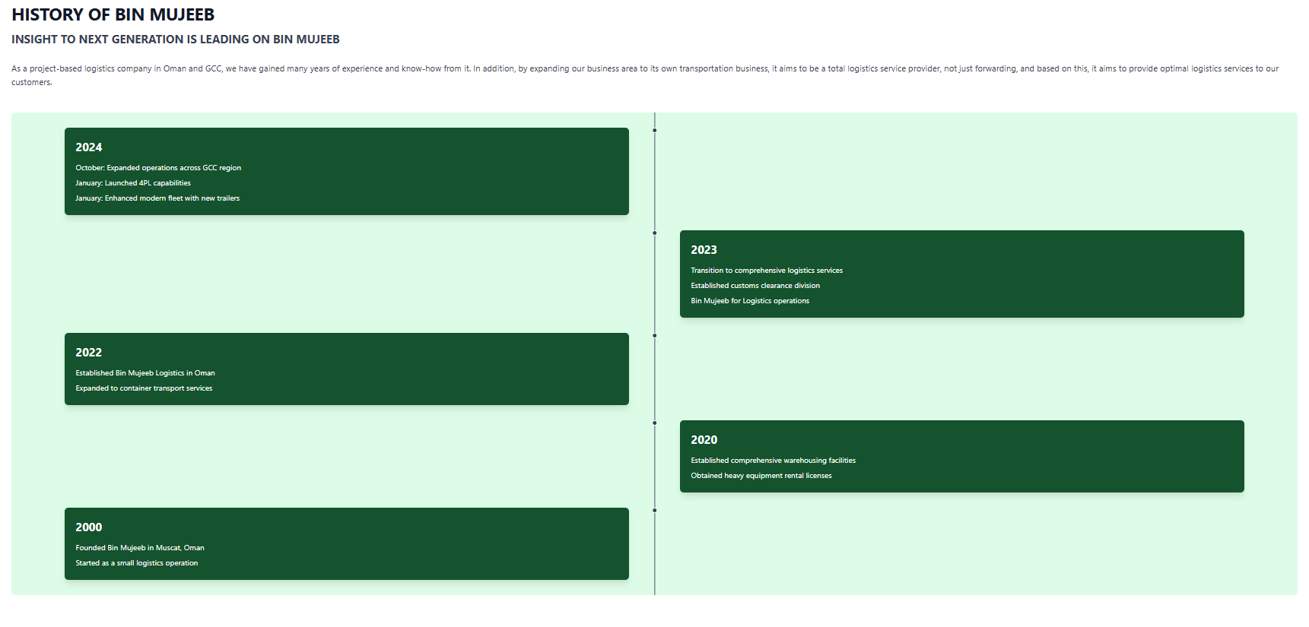

**Question 11A.1: What should be the main heading?**

Current Answer: HISTORY OF BIN MUJEEB

Your Updated Answer: _________________________________________________

**Question 11A.2: What should be the subtitle?**

Current Answer: INSIGHT TO NEXT GENERATION IS LEADING ON BIN MUJEEB

Your Updated Answer: _________________________________________________

**Question 11A.3: What should be the introductory paragraph?**

Current Answer: As a project-based logistics company in Oman and GCC, we have gained many years of experience and know-how from it. In addition, by expanding our business area to its own transportation business, it aims to be a total logistics service provider, not just forwarding, and based on this, it aims to provide optimal logistics services to our customers.

Your Updated Answer: _________________________________________________

**Question 11A.4: Please provide timeline events for each year (Year and events)**

Current Timeline:

2000: Founded Bin Mujeeb in Muscat, Oman | Started as a small logistics operation

2020: Established comprehensive warehousing facilities | Obtained heavy equipment rental licenses

2022: Established Bin Mujeeb Logistics in Oman | Expanded to container transport services

2023: Transition to comprehensive logistics services | Established customs clearance division | Bin Mujeeb for Logistics operations

2024: October: Expanded operations across GCC region | January: Launched 4PL capabilities | January: Enhanced modern fleet with new trailers

Your Updated Timeline:

Year: _________________________________________________

Events: _________________________________________________

(Please list all years and their corresponding events)

# **SECTION 11B: VISION PAGE**

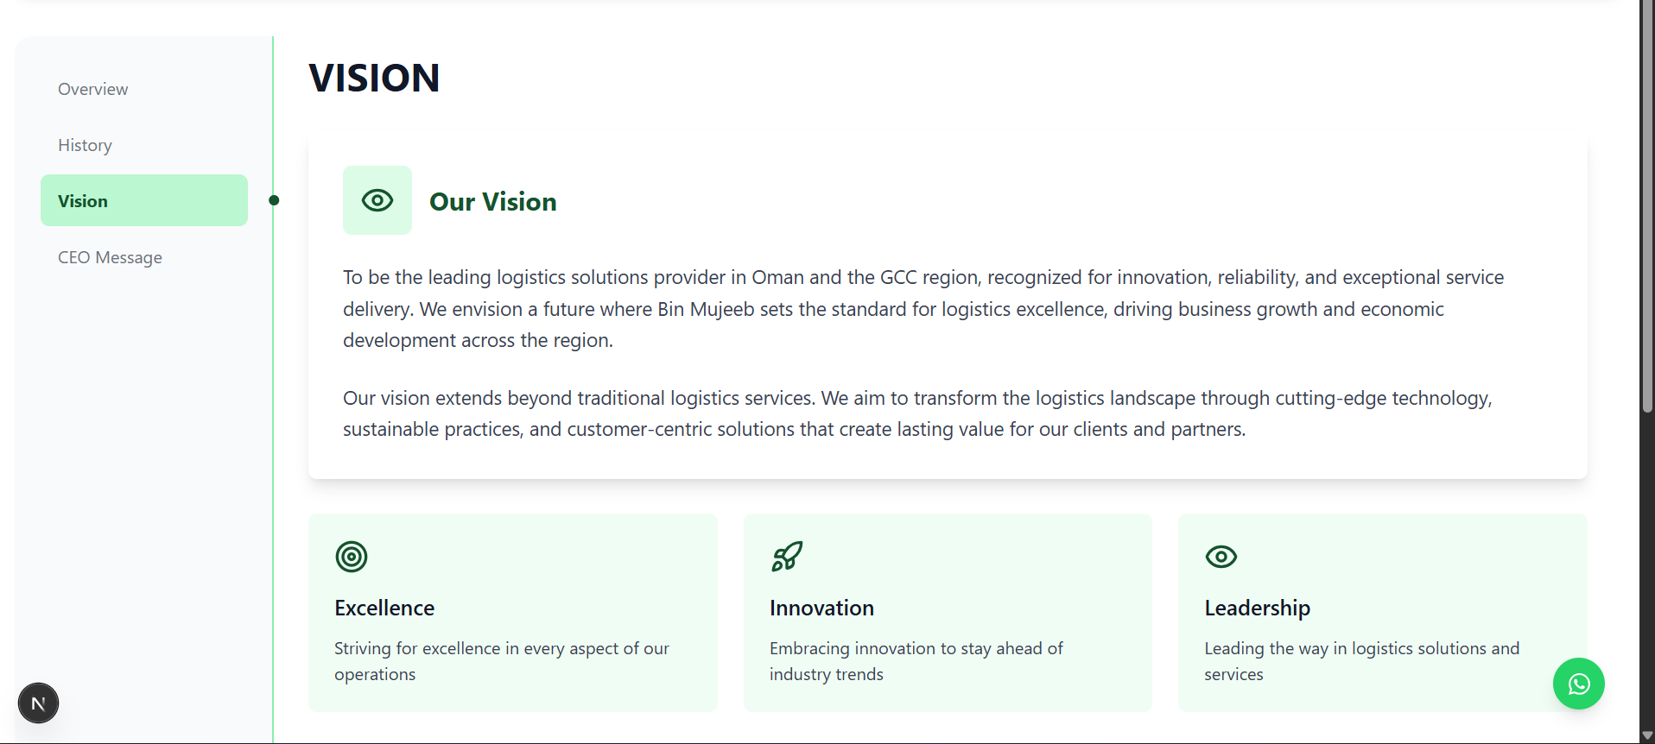

**Question 11B.1: What should be the main heading?**

Current Answer: VISION

Your Updated Answer: _________________________________________________

**Question 11B.2: What should be the main vision statement (first paragraph)?**

Current Answer: To be the leading logistics solutions provider in Oman and the GCC region, recognized for innovation, reliability, and exceptional service delivery. We envision a future where Bin Mujeeb sets the standard for logistics excellence, driving business growth and economic development across the region.

Your Updated Answer: _________________________________________________

**Question 11B.3: What should be the second paragraph of the vision statement?**

Current Answer: Our vision extends beyond traditional logistics services. We aim to transform the logistics landscape through cutting-edge technology, sustainable practices, and customer-centric solutions that create lasting value for our clients and partners.

Your Updated Answer: _________________________________________________

**Question 11B.4: What should be the three vision pillars? (Excellence, Innovation, Leadership)**

Current Answers:

Excellence: Striving for excellence in every aspect of our operations

Innovation: Embracing innovation to stay ahead of industry trends

Leadership: Leading the way in logistics solutions and services

Your Updated Answers:

Excellence: _________________________________________________

Innovation: _________________________________________________

Leadership: _________________________________________________

# **SECTION 11C: CEO MESSAGE PAGE**

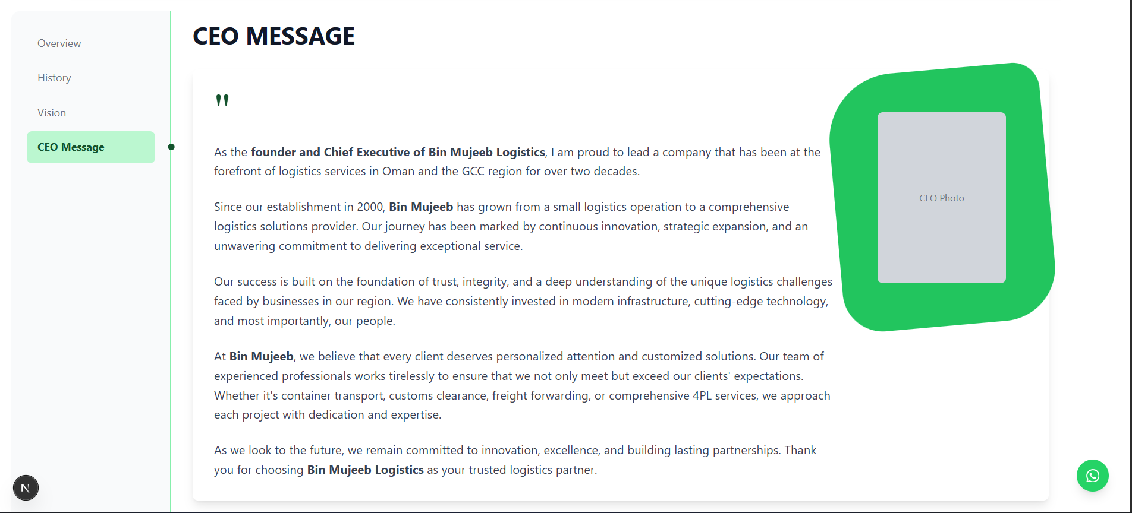

**Question 11C.1: What should be the main heading?**

Current Answer: CEO MESSAGE

Your Updated Answer: _________________________________________________

**Question 11C.2: What should be the first paragraph of the CEO message?**

Current Answer: As the founder and Chief Executive of Bin Mujeeb Logistics, I am proud to lead a company that has been at the forefront of logistics services in Oman and the GCC region for over two decades.

Your Updated Answer: _________________________________________________

**Question 11C.3: What should be the second paragraph?**

Current Answer: Since our establishment in 2000, Bin Mujeeb has grown from a small logistics operation to a comprehensive logistics solutions provider. Our journey has been marked by continuous innovation, strategic expansion, and an unwavering commitment to delivering exceptional service.

Your Updated Answer: _________________________________________________

**Question 11C.4: What should be the third paragraph?**

Current Answer: Our success is built on the foundation of trust, integrity, and a deep understanding of the unique logistics challenges faced by businesses in our region. We have consistently invested in modern infrastructure, cutting-edge technology, and most importantly, our people.

Your Updated Answer: _________________________________________________

**Question 11C.5: What should be the fourth paragraph?**

Current Answer: At Bin Mujeeb, we believe that every client deserves personalized attention and customized solutions. Our team of experienced professionals works tirelessly to ensure that we not only meet but exceed our clients' expectations. Whether it's container transport, customs clearance, freight forwarding, or comprehensive 4PL services, we approach each project with dedication and expertise.

Your Updated Answer: _________________________________________________

**Question 11C.6: What should be the closing paragraph?**

Current Answer: As we look to the future, we remain committed to innovation, excellence, and building lasting partnerships. Thank you for choosing Bin Mujeeb Logistics as your trusted logistics partner.

Your Updated Answer: _________________________________________________

**Question 11C.7: Please provide a high-resolution photo of the CEO**

Current Status: [Placeholder image - CEO Photo]

Please provide: High-resolution CEO photo (JPG or PNG format, recommended size: 800x1200px or similar portrait orientation)

# **SECTION 12: PROJECTS PAGE**

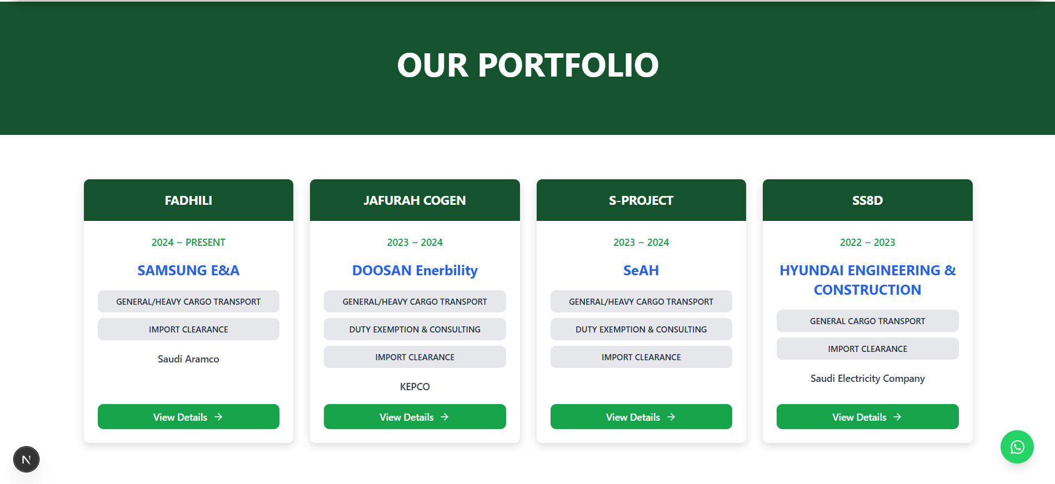

**Question 12.1: What should be the main heading?**

Current Answer: OUR PORTFOLIO

Your Updated Answer: _________________________________________________

**Question 12.2: Please provide details for each project card (Project Name, Date, Client, Services, Partner if any)**

Current Projects:

Project 1: FADHILI (2024 ~ PRESENT) - Client: SAMSUNG E&A - Services: GENERAL/HEAVY CARGO TRANSPORT, IMPORT CLEARANCE - Partner: Saudi Aramco

Project 2: JAFURAH COGEN (2023 ~ 2024) - Client: DOOSAN Enerbility - Services: GENERAL/HEAVY CARGO TRANSPORT, DUTY EXEMPTION & CONSULTING, IMPORT CLEARANCE - Partner: KEPCO

Project 3: S-PROJECT (2023 ~ 2024) - Client: SeAH - Services: GENERAL/HEAVY CARGO TRANSPORT, DUTY EXEMPTION & CONSULTING, IMPORT CLEARANCE

Project 4: SS8D (2022 ~ 2023) - Client: HYUNDAI ENGINEERING & CONSTRUCTION - Services: GENERAL CARGO TRANSPORT, IMPORT CLEARANCE - Partner: Saudi Electricity Company

Your Updated Projects:

Project 1: _________________________________________________

Project 2: _________________________________________________

Project 3: _________________________________________________

Project 4: _________________________________________________

**Question 12.3: OUR CLIENTS SECTION - Please provide company logo images for the sliding client logos section**

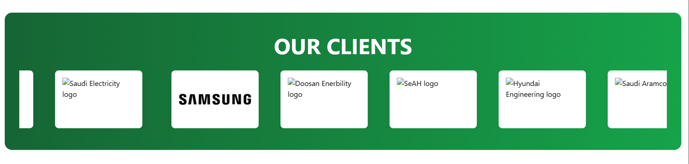

Current Client Companies Displayed:

• Samsung E&A

• Doosan Enerbility

• SeAH

• Hyundai Engineering & Construction

• Saudi Aramco

• KEPCO

• Saudi Electricity Company

Please provide:

1. High-resolution logo images (PNG format preferred, transparent background if possible)

2. Any additional client companies you would like to add to the sliding logos section

3. Any companies you would like to remove from the list

# **SECTION 13: CONTACT PAGE**

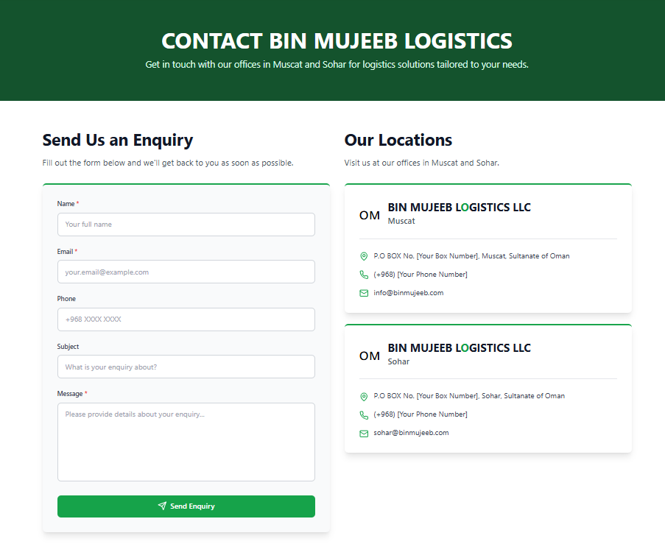

**Question 13.1: What should be the main heading?**

Current Answer: CONTACT BIN MUJEEB LOGISTICS

Your Updated Answer: _________________________________________________

**Question 13.2: What should be the subtitle?**

Current Answer: Get in touch with our offices in Muscat and Sohar for logistics solutions tailored to your needs.

Your Updated Answer: _________________________________________________

**Question 13.3: Please provide contact details for each location (Muscat and Sohar only)**

Current Answers:

Muscat: P.O BOX No. [Your Box Number], Muscat, Sultanate of Oman | Phone: (+968) [Your Phone Number] | Email: info@binmujeeb.com

Sohar: P.O BOX No. [Your Box Number], Sohar, Sultanate of Oman | Phone: (+968) [Your Phone Number] | Email: sohar@binmujeeb.com

Your Updated Answers:

Muscat - Address: _________________________________________________

Muscat - Phone: _________________________________________________

Muscat - Email: _________________________________________________

Sohar - Address: _________________________________________________

Sohar - Phone: _________________________________________________

Sohar - Email: _________________________________________________

# **SECTION 14: FOOTER & WHATSAPP BUTTON**

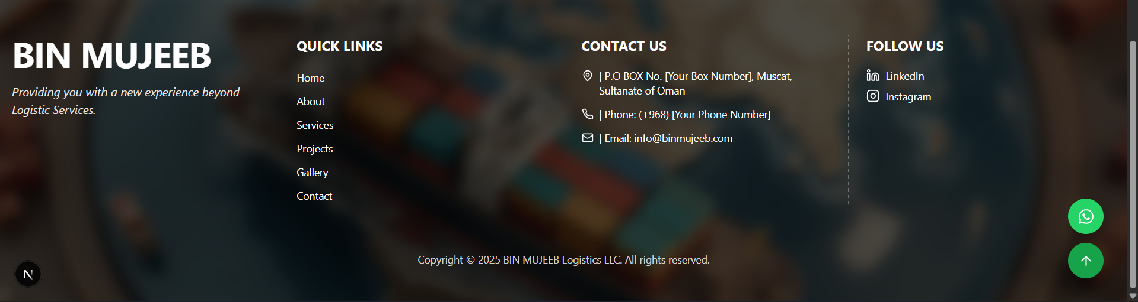

**Question 14.1: What should be the company tagline?**

Current Answer: Providing you with a new experience beyond Logistic Services.

Your Updated Answer: _________________________________________________

**Question 14.2: What should be the copyright text?**

Current Answer: Copyright © 2025 BIN MUJEEB Logistics LLC. All rights reserved.

Your Updated Answer: _________________________________________________

**Question 14.3: WHATSAPP CONTACT NUMBER - Please provide your WhatsApp business number**

Current Answer: [Placeholder - 968XXXXXXXXX]

Please provide:

1. WhatsApp Number (format: country code + space + number, eg. +91 968xxxxxxx): _________________________________________________

2. Default message for WhatsApp (optional - currently: 'Hello, I would like to know more about Bin Mujeeb Logistics services.'): _________________________________________________

# **SECTION 15: SERVICES CAROUSEL (HOME PAGE)**

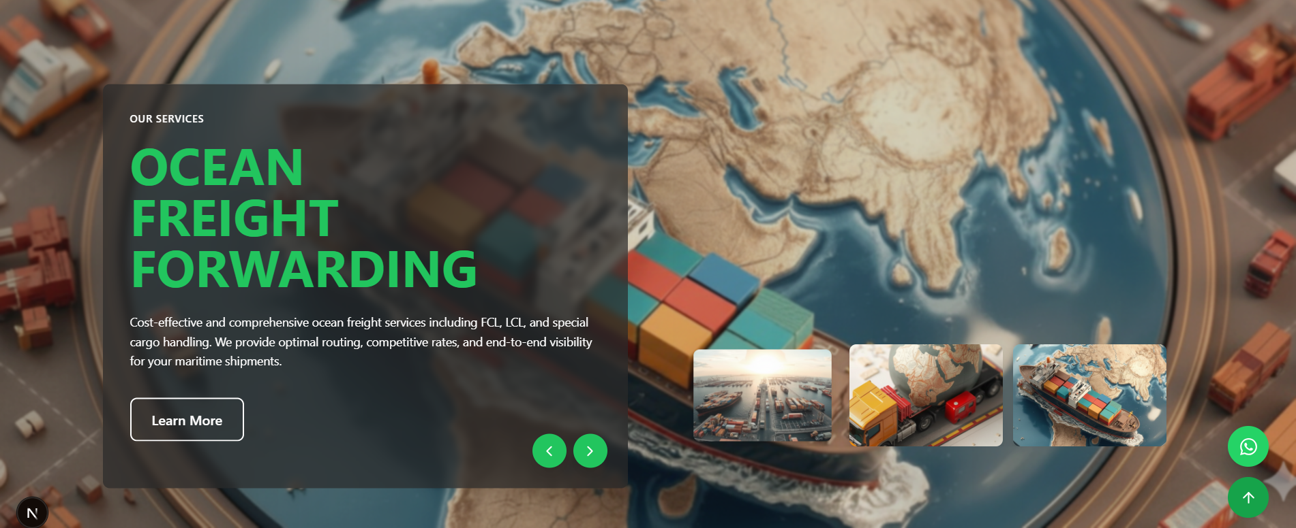

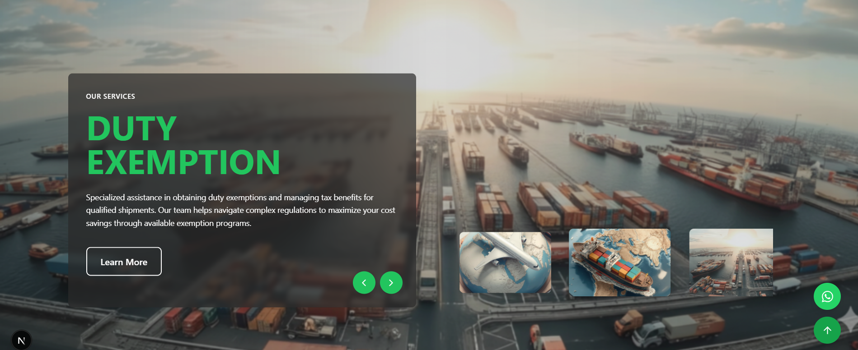

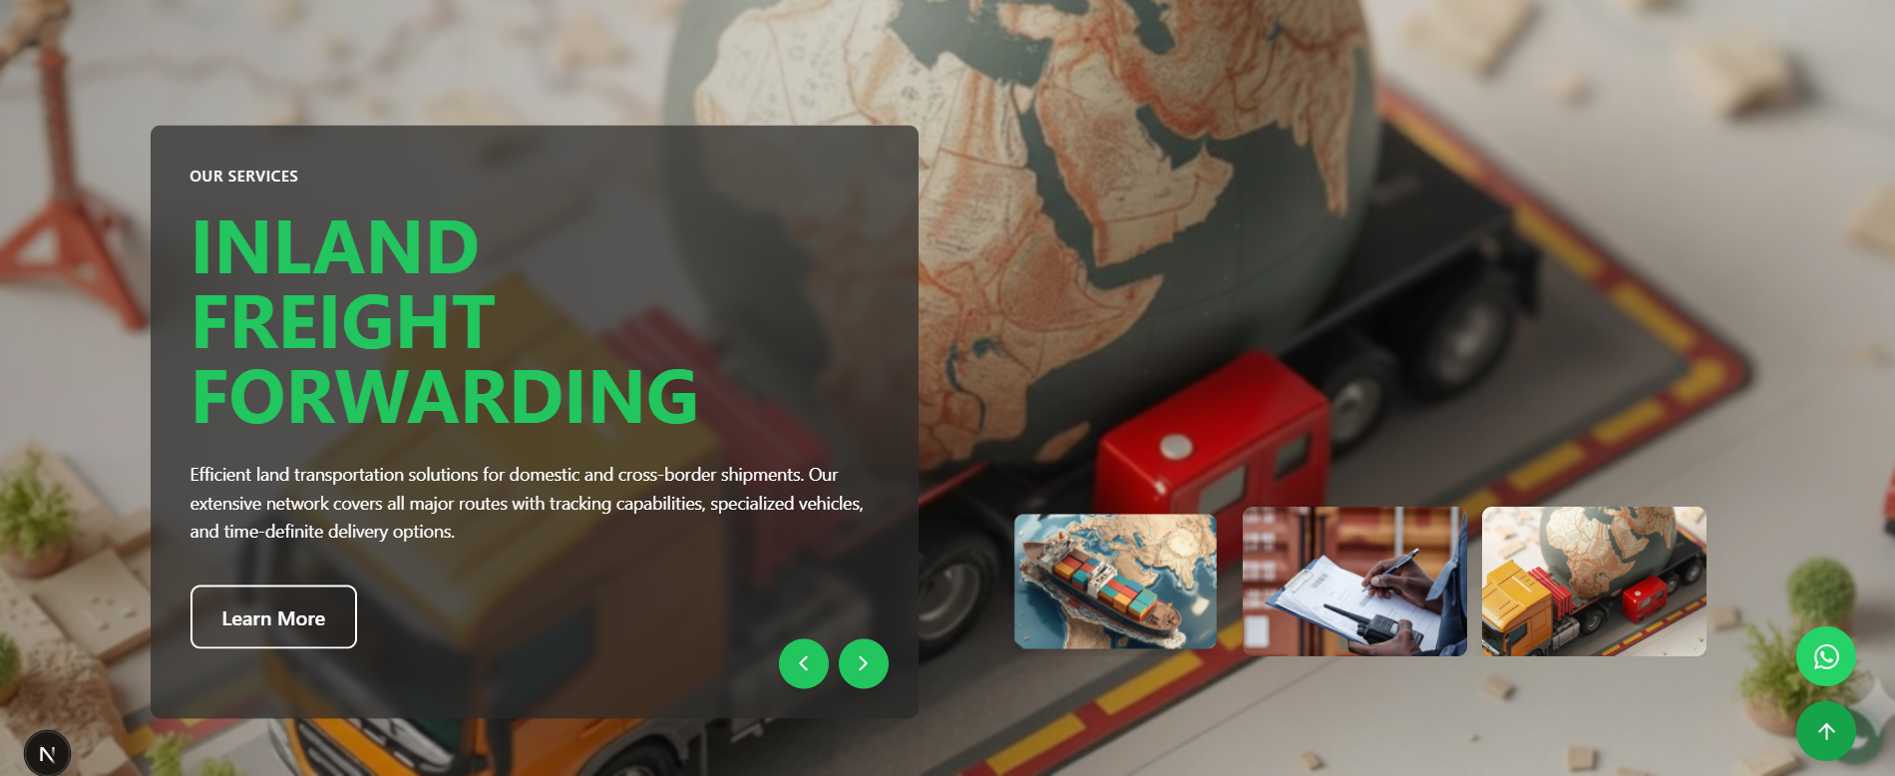

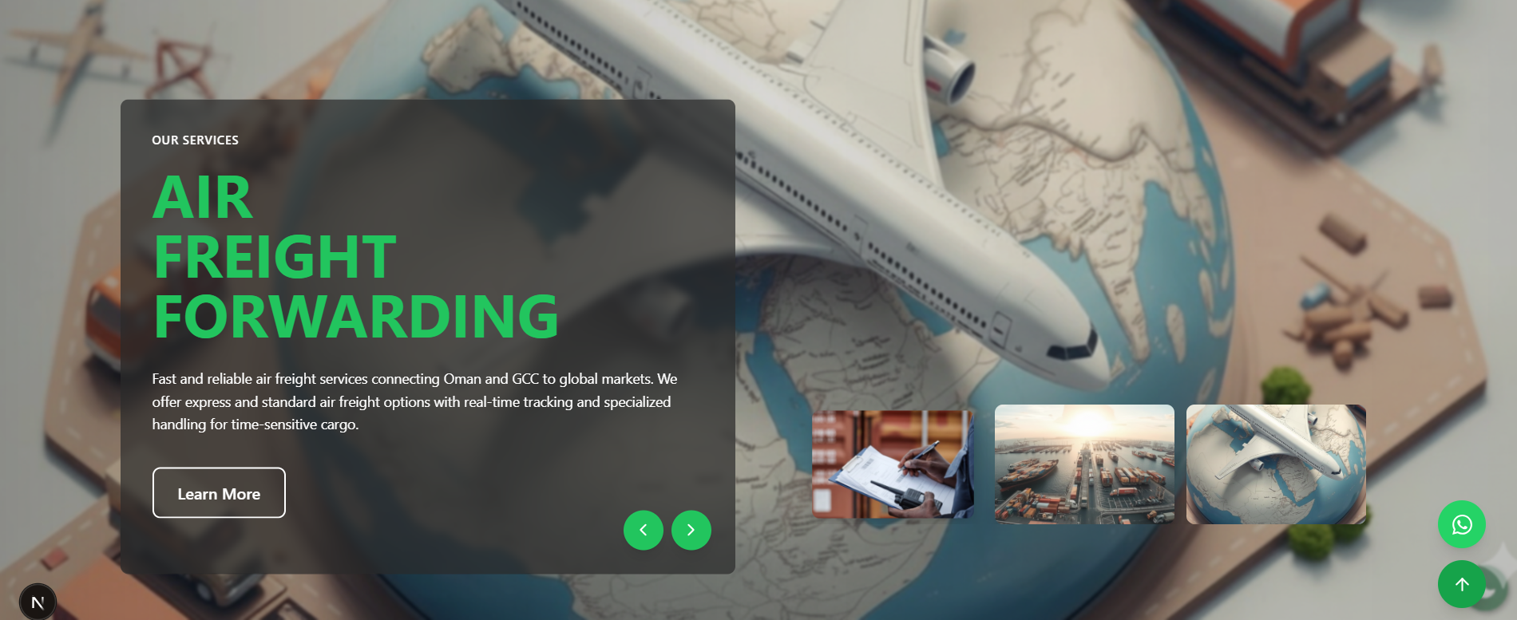

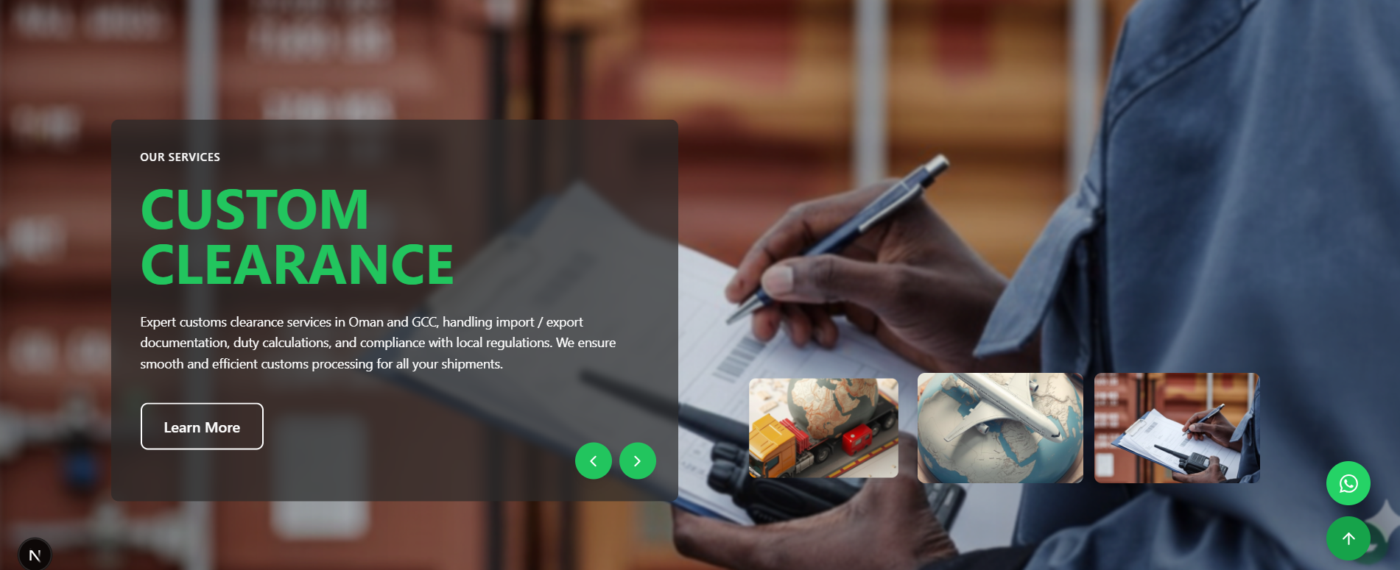

**Question 15.1: AIR FREIGHT FORWARDING - What should be the description?**

Current Answer: Fast and reliable air freight services connecting Oman and GCC to global markets. We offer express and standard air freight options with real-time tracking and specialized handling for time-sensitive cargo.

Your Updated Answer: _________________________________________________

**Question 15.2: OCEAN FREIGHT FORWARDING - What should be the description?**

Current Answer: Cost-effective and comprehensive ocean freight services including FCL, LCL, and special cargo handling. We provide optimal routing, competitive rates, and end-to-end visibility for your maritime shipments.

Your Updated Answer: _________________________________________________

**Question 15.3: CUSTOM CLEARANCE - What should be the description?**

Current Answer: Expert customs clearance services in Oman and GCC, handling import / export documentation, duty calculations, and compliance with local regulations. We ensure smooth and efficient customs processing for all your shipments.

Your Updated Answer: _________________________________________________

**Question 15.4: DUTY EXEMPTION - What should be the description?**

Current Answer: Specialized assistance in obtaining duty exemptions and managing tax benefits for qualified shipments. Our team helps navigate complex regulations to maximize your cost savings through available exemption programs.

Your Updated Answer: _________________________________________________

**Question 15.5: INLAND FREIGHT FORWARDING - What should be the description?**

Current Answer: Efficient land transportation solutions for domestic and cross-border shipments. Our extensive network covers all major routes with tracking capabilities, specialized vehicles, and time-definite delivery options.

Your Updated Answer: _________________________________________________

# **END OF DOCUMENT**

Thank you for reviewing this document. Please fill in your updated answers and return this document. We will update the website content accordingly.